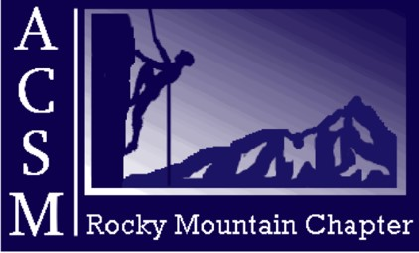
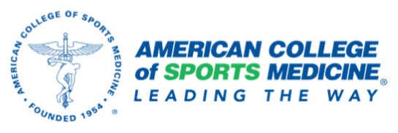

RMACSM
Abstract/Poster Guidelines
The upcoming Annual Meeting of the Rocky Mountain Chapter of the American College of Sports Medicine will be held at University of Colorado, Colorado Springs campus in Hybl Sports Medicine and Performance center on April 12th and April 13th, 2024. Poster presentations are scheduled on Friday, April 12th and will be presented in two blocks: Block A 5:15 – 6:00 PM, Block B 6:15 – 7:00 PM. Winners will be announced on Saturday, April 13th after lunch.
Please note that both presenter and faculty sponsor must be RMACSM chapter members in order to be eligible for monetary awards. Membership details and renewal information can be found at
https://www.acsm.org/acsm-membership/membership/join
Awards will be given at each of the following levels:
Doctoral Student, Masters Student, Undergraduate Student
1st: $150 2nd: $100 3rd: $50
President’s Cup Competition: The student trainee chosen as the regional chapter winner must attend the National ACSM Annual Meeting to present their work in the national-level competition. The RMACSM chapter winner is awarded a complimentary registration to the national ACSM Annual Meeting. The National President’s Cup Competition winner will be presented with a plaque and an additional $300 will be sent to the winner after the conclusion of the annual conference. Note: only Master’s and Doctoral level posters are eligible for the President’s Cup. Undergraduates and Post-docs, while not eligible for the President’s Cup, are eligible for RMACSM cash awards.
ABSTRACT PREPARATION (sample abstract on page 2).
Title: Limited to 15 words and should be typed in title case.
Authors: Include the first and last names of all authors. Do not include degrees.
Affiliations: Provide the name and location of the institution for all authors. Do not include departments.
Text: Abstracts should be single spaced in 12 point times new roman font and are limited to 2,000 characters (not including spaces, title, or author information). Each abstract should be structured with headings for PURPOSE, METHODS, RESULTS, and CONCLUSION. If including table, chart, or graph, the limit is 1,500 characters.
Abstract Category: Select 1-2 categories that represent the intended focus of your abstract.
Cardiovascular Clinical Populations
Skeletal muscle, bone and connective tissue Sports Performance
Biomechanics Sports Medicine
Environmental Physiology Metabolism and nutrition
Exercise is Medicine Cancer
Epidemiology Proposed Research
Physical Activity Monitoring Uncategorized
SUBMISSION INSTRUCTIONS:
Submit your abstract by clicking on “Submit your abstract online” on the (UPDATE THIS LINK): RMACSM website. With submission, please note your abstract category and indicate if you do NOT wish to be judged and eligible for the Poster and Presentation Competition. The deadline for submission is by 5pm Friday, March 15th, 2024. Presenters will be notified of programming by March 29th, 2024.

Scientific Abstract Example
ABSTRACT TITLE and AUTHOR BLOCK IS NOT TO BE INCLUDED IN ABSTRACT BODY AT TIME OF SUBMISSION
TITLE HAS A 15 WORD LIMIT

Mechanisms Underlying Age-Related Changes in Skin Vasodilation During Local Heating

Christopher T. Minson, Lacy A. Holowatz, W. Larry Kenney, FACSM, Brett J. Wong, Brad W. Wilkins.
University of Oregon, Eugene, OR, Penn State University, University Park, PA

The skin blood flow (SkBF) response to local heating is reduced in healthy older (O) vs. young (Y) subjects; however, the mechanisms that underlie these age-related changes are unclear. Local skin heating causes a bimodal rise in SkBF involving at least two independent mechanisms: an initial peak mediated by axon reflexes and a secondary slower rise to a plateau which is mediated by the local production of nitric oxide (NO). PURPOSE: To determine the altered mechanism(s) underlying the attenuated SkBF response to local heating in aged skin. METHODS: Two microdialysis fibers were placed in the ventral skin of the forearm of 10 Y (22+2 yrs) and 10 O (77+5 yrs) subjects. SkBF over each site was measured by laser-Doppler flowmetry as the skin over both sites was heated to 42˚ C for ~60 min. At one site, 1OmM L-NAME was infused throughout the protocol to inhibit NO-synthase (NOS). At the second site L-NAME was infused after 40 min of local heating. Cutaneous vascular conductance (CVC) was calculated as flux/mean arterial pressure and scaled as % maximal CVC (infusion of 50mM sodium nitroprusside). Age comparisons were made using two-way ANOVA with repeated measures. RESULTS: Maximal CVC was reduced in the O (l56+15 vs. 192+12 mV/mmHg, p<0.05), as were the initial peak (46+4 vs. 61+2% max, p<0.05) and plateau (82+5 vs. 93+2%, p<0.05) responses. The decline in CVC with NOS inhibition during the plateau phase was similar in the Y and O groups but the initial peak was significantly lower in O when NOS was inhibited prior to local heating (38+5 vs. 52+4%, p<0.05). CONCLUSION: Age-related changes in both axon reflex-mediated and NO-mediated vasodilation contribute to the diminished vasodilator response to local heating in aged skin. Supported by NIH Grant ROI AG07004.
ABSTRACT BODY HAS A 2,000 CHARACTER COUNT LIMIT (not including spaces, title, or author block)

