

SWACSM 2024
Abstract Submission Information
SWACSM General Abstract Submissions &
SWACSM Expanded Abstracts for the Student Research Award Competition

Expanded Abstracts for the Student Research Award Competition Due Friday, September 13, 2024, 5:00 pm, PDT

General Abstracts Due Friday, September 20, 2024, 5:00pm, PDT

Abstract Submission Link: https://digitalcommons.wku.edu/ijesab/
SWACSM 2024 Abstract Submission Instructions
SWACSM Annual Meeting and Conference, starting Friday, October 25, 2024.
All members and those joining the Southwest Chapter of the American College of Sports Medicine (SWACSM) are invited to submit abstracts for presentations, either as a general poster presentation or in our student research award competition.
Please follow the general and/or student research award specific instructions for submission.

General Abstracts- Poster Presentations Specific Instructions
- All abstract submissions are required in electronic format. The poster sessions are scheduled for Friday October 25, 2024 and Saturday October 26, 2024. Poster presenters will only be assigned to present at 1 of these sessions.
- Each individual is permitted to be first author on only one abstract, but may co-author several abstracts.
- The first author is considered the presenter and must present the abstract at the meeting.
- At least one of the authors must be a member of the SWACSM.
- If one of the authors is a Fellow of the American College of Sports Medicine (ACSM), the letters FACSM should follow their name.
- All general abstracts will undergo a blind review to ensure that all submission directions were followed as well as to assess the quality and appropriateness of the research for the SWACSM Annual Meeting and Conference.
- General abstracts (maximum 2000 characters without spaces) will be published in the program as submitted. Please check for spelling errors prior to submission. Abstracts must be submitted using the SWACSM template provided. All template formats, fonts, etc. must be followed. Deviateing from the SWACSM template may result in reviewers requesting revisions and/or the abstract being rejected.
- Abstract subheadings should follow ACSM requirements; purpose, methods, results, and conclusions. See the SWACSM template for more information.
- Abstracts should not have been published previously in any other printed or electronic format as abstracts will be published in the International Journal of Exercise Science. Publishing will be delayed so authors can also submit their abstracts to national ACSM if they so choose.
- For students, presenting at SWACSM does not preclude submitting the same abstract for presentation at the ACSM National Meeting.
- Keep a copy of the abstract for your records.
- Following submission of a general abstract for poster presentation, an electronic email confirmation will be sent to the applicant and co-authors (if co-author emails are provided). Email notification of acceptance, revisions, or rejection, as well as presentation information, will be sent after the the general abstract deadline from one of the SWACSM Abstracts and Awards committee members, Dr. Jeff Bernard (jbernard1@csustan.edu), Dr. Sarah Camhi (scamhi2@usfca.edu), or Dr. Matt Seeley. (matt_seeley@byu.edu). If you do not receive the email notification, check that you included the correct email address free of spelling errors or check your junk mail or SPAM folders. You can contact the SWACSM Abstracts and Awards members, if you believe you did not receive an email confirmation.
- In the Cover Page Footnote dialogue box of the submission you will have the option of choosing a preferred poster presentation day (Friday or Saturday). Suggestions will be taken into consideration but the presentation day cannot be guaranteed.
- All general poster presenters are expected to create a visual poster. See example below.

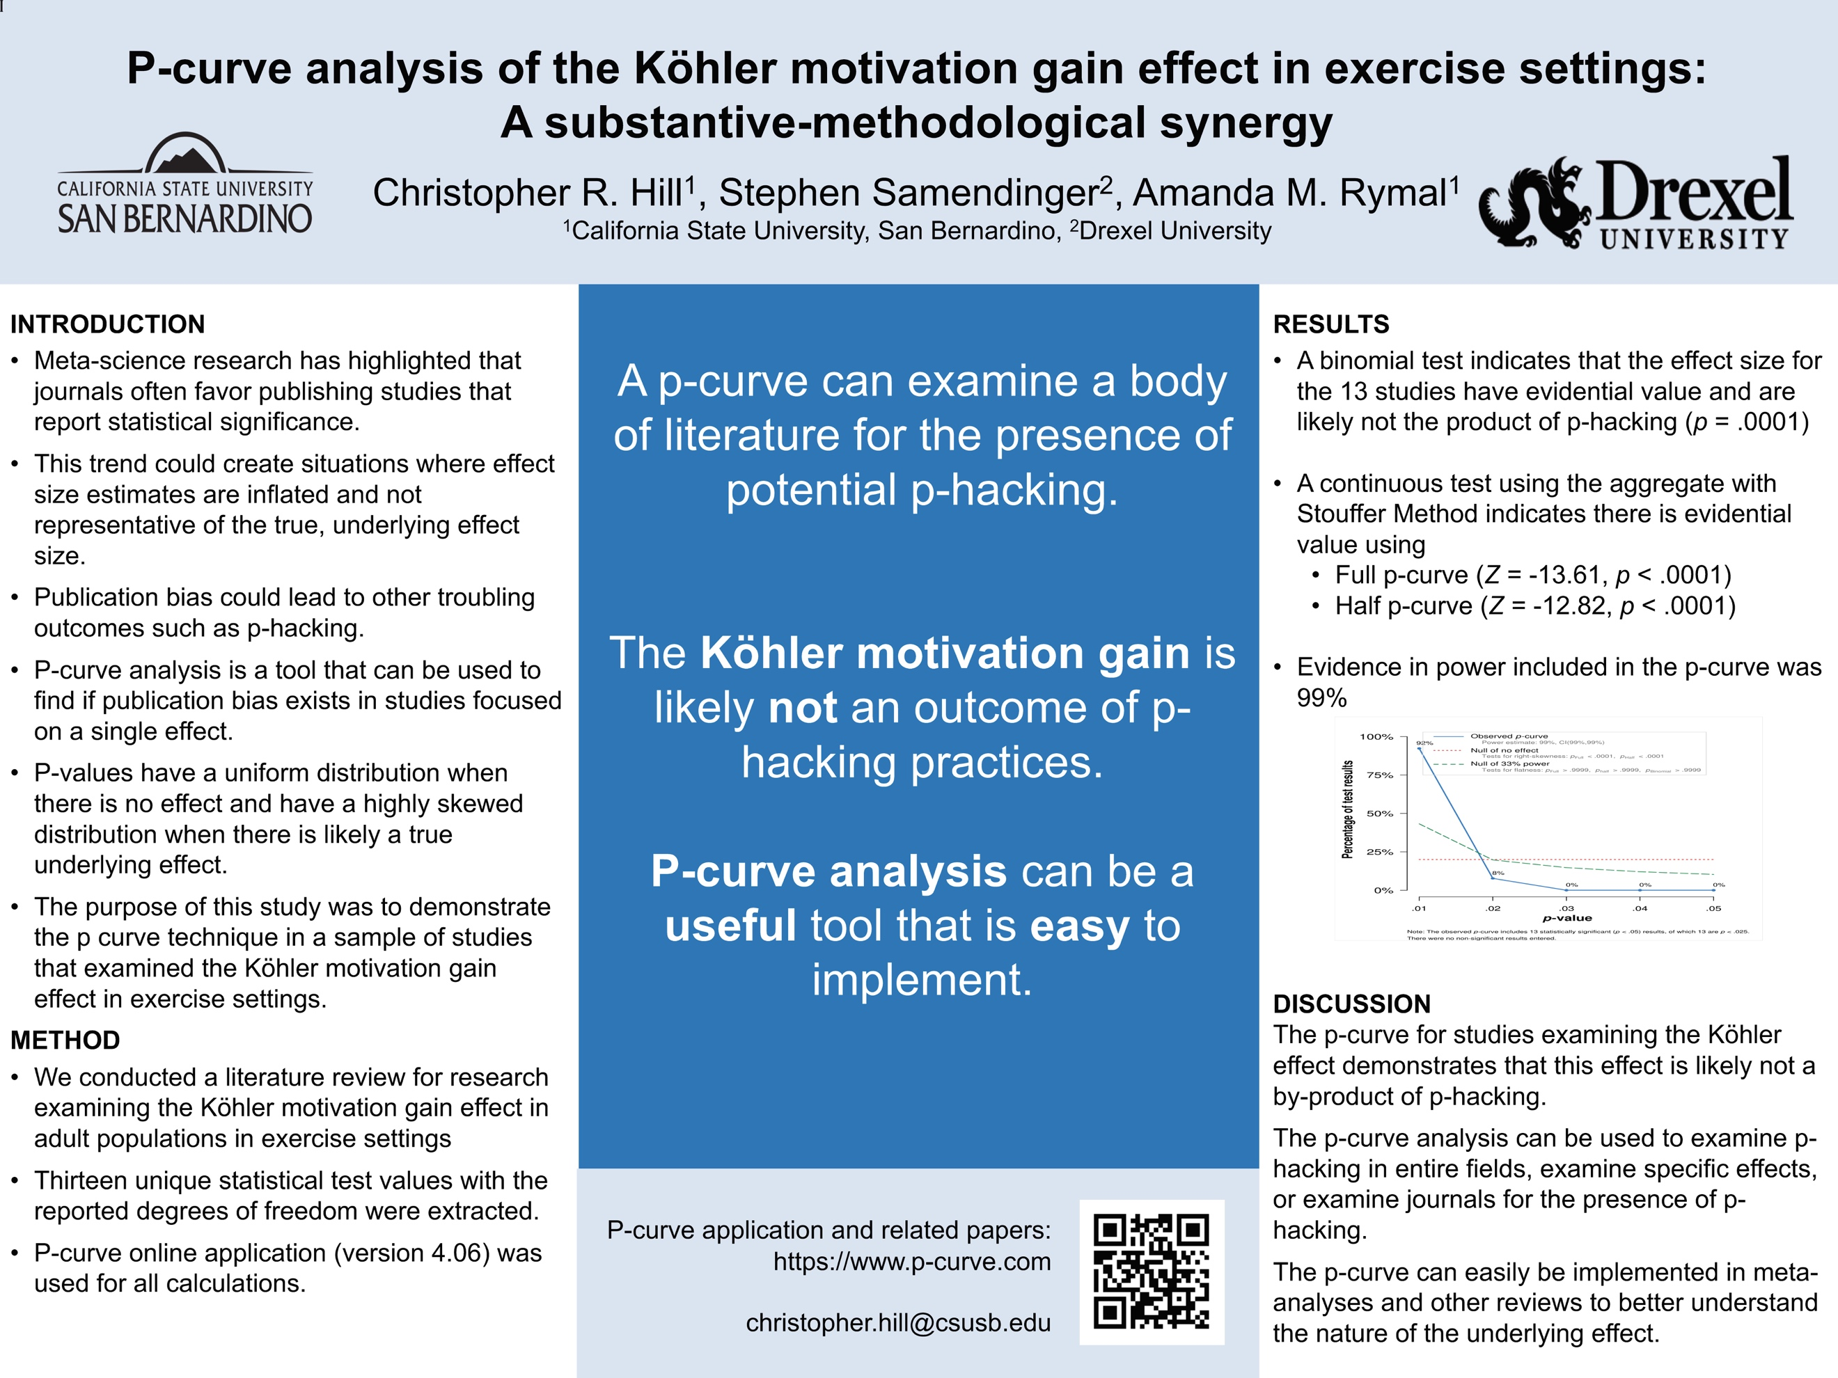

Expanded Abstracts-Student Research Award Competition Specific Instructions
- All expanded abstract submissions are required in electronic format. The student research award competition question and answer (Q&A) sessions are scheduled for Friday, October 25, 2024.
- If you are submitting your expanded abstract for the student research award competition, you must indicate this in the electronic submission form due Friday September 13, 2024 AND you must submit both a brief and an expanded abstract for consideration by the deadline Friday, September 13, 2024.
- Each individual is permitted to be first author on only one abstract, but may co-author several abstracts.
- The first author is considered the presenter and must present the abstract at the meeting.
- At least one of the authors must be a member of the SWACSM.
- If one of the authors is a Fellow of the American College of Sports Medicine (ACSM), the letters FACSM should follow their name.
- All expanded abstracts will undergo a blind review by three experts in the field for the competition while the brief abstract will be included in the program.
- The expanded abstract is limited to 5 pages (not counting references) and must be double spaced. Minimum acceptable type size will be 11 cpi and no larger than 12 cpi. Arial type font is required. Please check for spelling errors prior to submission.
- The expanded abstract should provide the study's background, purpose, design/methods, results (including optional tables and figures), discussion and conclusions.
- If the expanded abstract does not follow the above format, it will be returned to the first author for revisions. Revisions must be submitted no later Friday, September 20, 2024 for continued consideration in the competition.
- Be sure to include the name of your advisor/mentor and his/her email address. An email message may be sent to your advisor/mentor verifying your student status and to confirm the expanded abstract is appropriate for presentation at the SWACSM Annual Meeting and Conference.
- All work reported in the expanded abstract must have been conducted while you were a registered student at an institution in the Southwest Region and the abstract may have multiple authors/investigators although only one individual is to present.
- Abstracts should not have been published previously in any other printed or electronic format.
- Keep a copy of the abstract for your records.
- Following submission of an expanded abstract for the student research award competition, an electronic email confirmation will be sent to the applicant and co-authors (if co-author emails are provided). Email notification of acceptance, revisions, or rejection, as well as presentation information, will be sent after the the general abstract deadline from one of the SWACSM Abstracts and Awards committee members, Dr. Jeff Bernard (jbernard1@csustan.edu), Dr. Sarah Camhi (scamhi2@usfca.edu), or Dr. Matt Seeley. (matt_seeley@byu.edu). If you do not receive the email notification, check that you included the correct email address free of spelling errors or check your junk mail or SPAM folders. You can contact the SWACSM Abstracts and Awards members, if you believe you did not receive an email confirmation.
- Five student presenter finalists for each level, undergraduate and graduate, will be asked to present an oral presentation on Friday, October 25, 2024.
- All expanded abstracts NOT selected for the competition will be asked to present as a general poster presentation.
- The Undergraduate Student Research Award Competition is scheduled for 11am-12:30pm on Friday, October 25, 2024.
- The Graduate Student Research Award Competition is scheduled for 1:45pm-3:15pm on Friday, October 25, 2024.
- Following review of the finalists by competition judges, winners of each competition will be announced in the General Session held on Saturday October 26, 2024 from 9:15am-10:45am.
- Additionally, one overall winner from the Undergraduate and Graduate Student Research Award Competition winners will be named and asked to represent the chapter at the ACSM National President’s Cup Competition.
All questions regarding abstract submissions or the student research award competition can be directed to:
Dr. Jeff Bernard, SWACSM Abstracts and Awards Committee
Department of Kinesiology and Publich Heath Promotion, California State University, Stanislaus
Email: Jbernard1@csustan.edu
Access the International Journal of Exercise Science Conference Proceedings site at: https://digitalcommons.wku.edu/ijesab

Click on “Submit Abstract” (left side menu)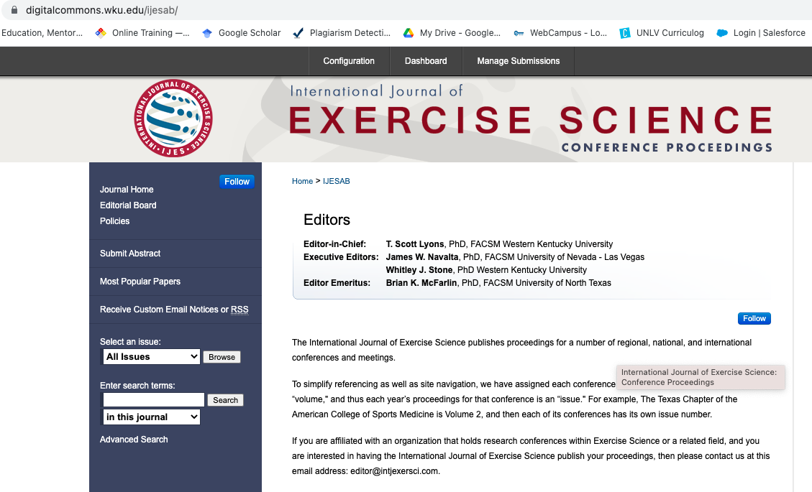

Have your title (in Title case), author emails, and SWACSM abstract template saved in a known location. Click “Continue”

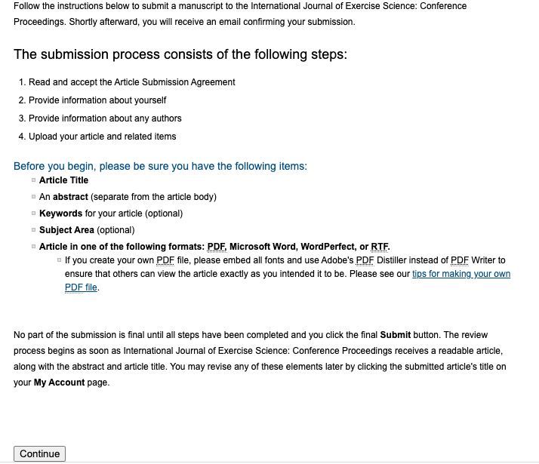
Read the Article Submission Agreement and click “Accept”
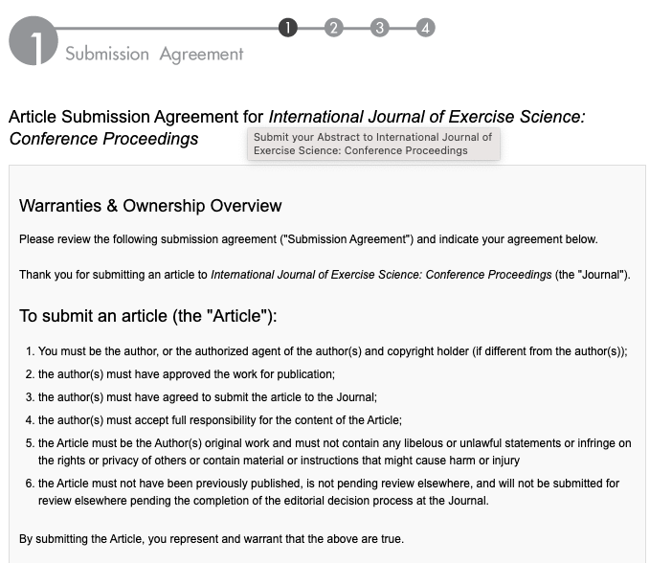
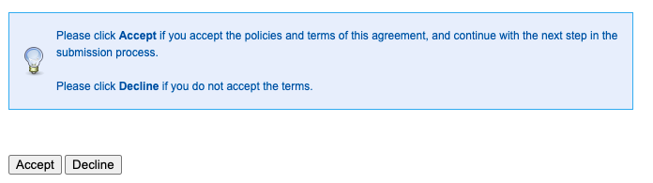

Enter your First/Given name, Last/Family name, and Institutional Affiliation.

**If you are a Fellow of the American College of Sports Medicine, enter FACSM in the suffix dialogue box.

Click “Continue”

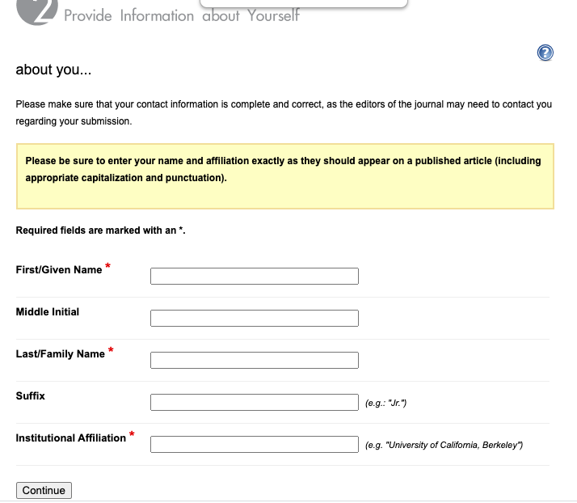

Click “Add author” to include coauthors.

Then add the required information and click “Add to list of authors”.
**If a coauthor is a Fellow of the American College of Sports Medicine, enter FACSM in the suffix dialogue box.

Repeat until all coauthors are included.

Then click “Continue”
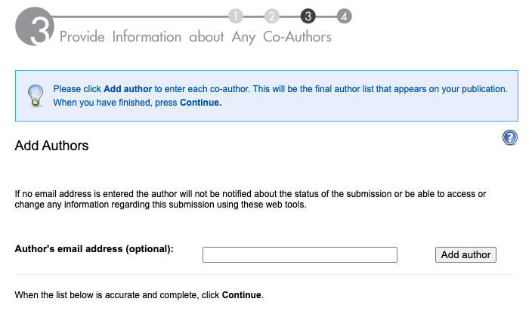

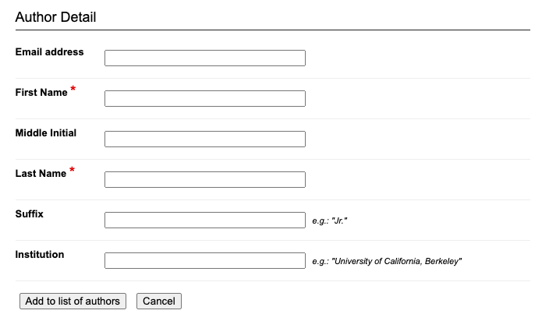

Enter the article title (it is not necessary to enter a short title, key words, or select a subject area)
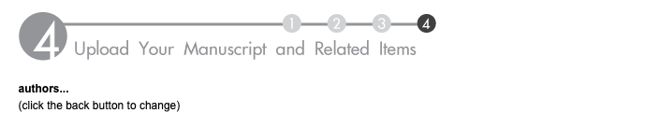
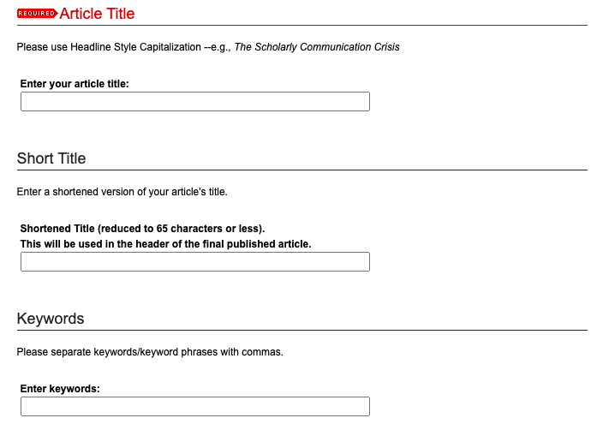

For submission type, select Southwest ACSM Abstract

**NOTE: If submitting for the student research competition, select either “Student Research Competition – Undergraduate” or “Student Research Competition – Graduate” (instead of Southwest ACSM Abstract)
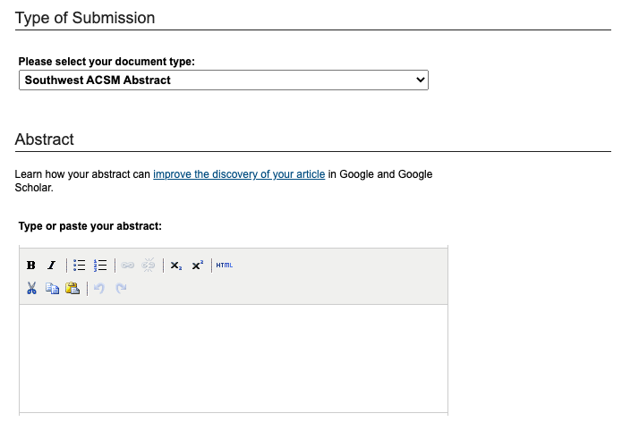
Paste your abstract into the Abstract dialogue box

In the Cover Page Footnote dialogue box, enter your preferred presentation date (Friday or Saturday)

Upload the template containing your SWACSM abstract using the Full Text of Submission radio button.
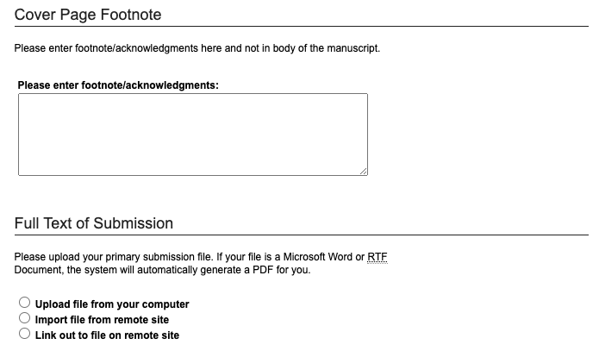
You do NOT need to include a cover letter
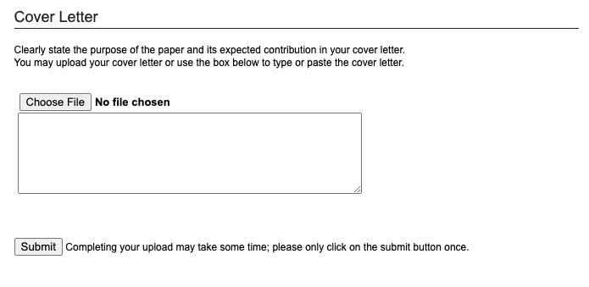
Finally, click “Submit” one time.
You will receive an email confirmation that your abstract has been submitted.

