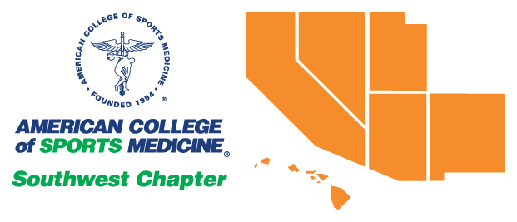
  - Summer 2023: Vol 36, No. 3

Southwest American College of Sports Medicine

President Elect’s Column
I’m hoping many of you had a productive summer and are prepared for the start of the Fall terms. As I have just completed my civic duty, I am excited to turn my attention to our upcoming annual meeting and am encouraging many of you to attend. The annual meeting is being held at the Costa Mesa/Orange County Hilton on October 27-28. We have a wide array of speakers that are presenting on a multitude of topics, which I hope you all enjoy. If you are planning to attend and/or present, here are some highlights of the program.
In addition to Dr. Irene Davis and Dr. J. Jay Dawes speaking at our general sessions, we are excited to welcome Dr. Khalil Lee from the Gatorade Sports Science Institute and will be presenting on Sweat Testing for Heat Safety. Additionally, we have several muscle physiology presentations, including New Insights About the Consequences of the Exposure to Tobacco Products on Cardiac and Skeletal Muscle presented by researchers from San Diego State and University of California, San Diego. Another exciting talk is coming from California State University, Northridge researchers titled Augmented and Virtual Reality for Gait and Balance Rehabilitation: Benefits, Challenges, and Future Outlook, which I’m sure is to capture the interest of students interested in VR. We have several other talks planned and I hope there is something that will pique the curiosity of you all.
Finally, I am excited to announce that there will be a faculty social Friday afternoon. This will be an opportunity for faculty to gather and network with other faculty and professionals in the region. Additionally, there will be a Faculty/Student breakfast Saturday morning. This will provide students with an opportunity to meet with faculty and professionals in the region and connect for potential graduate student opportunities. Faculty will be solicited to attend in the coming weeks and students are also encouraged to attend.
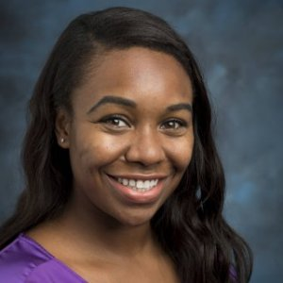
I hope to see many of you in Southern California for this exciting SWACSM conference. And please remember that you can always reach out to me (jenevieve.roper@lmu.edu) with questions/comments/concerns regarding the state of our chapter and its future directions. Have a great semester and see you in October!

Jenevieve Roper, Ph.D.
SWACSM President-Elect

SWACSM elections
We are pleased to announce the results of the SWACSM Board of Trustees elections. Kenneth Vitale MD, FACSM, FAAPMR, CAQSM, will serve as the new President-Elect. Matthew Seeley, PhD, FASCSM, ATC, will serve as the new Member-at-Large for the Abstracts & Awards Committee. Congratulations to our new Board members! Thank you to all of the candidates for participating and to all of the members who voted!

2023 sWACSM Annual meeting October 27-28th

Please save the date for our upcoming regional chapter meeting at the Orange County Costa Mesa Hilton Hotel in Costa Mesa, CA. Registration for the conference is available here.
The deadline to submit applications for the student travel grant and Ruby grant is September 15th. Research abstract submissions for the annual meeting poster session are due September 22nd. Submission instructions will be available on our website beginning July 1st. As usual, we will be hosting a student research competition. Competitors should be prepared to submit an expanded abstract for the competition by September 15th. We will also continue the annual Jeopardy bowl competition on sports medicine knowledge for teams of three undergraduate students from institutions within the region which will be held at the SWACSM meeting on Friday evening, October 27th. Teams interested in participating in jeopardy should contact Dr. Sarah Camhi by October 13th, 2023.
The conference hotel is offering members a discount and special meeting rates for lodging. Please use this link to book your hotel by September 26th.

seeking swacsm recognition award nominations
Do you know of someone who has made significant contributions to the field of sports medicine or exercise science through scholarly achievement and/or service to SWACSM? If so, please consider submitting a nomination for the SWACSM Recognition Award. We give out one award each year at our annual meeting in October. 2023 nominations are due by September 5th, 2023. The board keeps all nominations on file, so if your nominee is not chosen this year, they will remain in consideration for future years. For a list of previous winners, please visit our website.

Congratulations to the New FEllows of the American College of Sports Medicine
Congratulations to all of the new Southwest American College of Sports Medicine members who have been named fellows of the American College of Sports Medicine in 2023!
- Christopher Berger, Ph.D., FACSM, Occidental College
- Jeffrey Bernard, Ph.D., FACSM, California State University, Stanislaus
- Jeffrey Christle, Ph.D., FACSM, Stanford University
- Sarah Keadle, Ph.D., FACSM, California Polytechnic State University
- Michele LeBlanc, Ph.D., FACSM, California Lutheran University
- Shlomit Radom-Aizik, Ph.D., FACSM, University of California Irvine
- Matthew Seeley, Ph.D., FACSM, Brigham Young University
- Christian Thompson, Ph.D., FACSM, University of San Francisco

RESEARCH SPOTLIGHT

We would like to highlight research from our chapter! If you have had a publication since May 1st, 2023 please email the reference details including authors, year of publication, article title, journal title, volume number, issue number, and page numbers, as appropriate, to Zachary Zenko (zzenko@csub.edu). APA formatting preferred. We will be highlighting these publications in the Winter newsletter. Here are some recent publications from our members!

Almeida, A. A., Reeve, E. H., Dickinson, R. L., Carty, M., Gilpin, J., & Feairheller, D. L. (2022). Civilians have higher adherence and more improvements in health with a Mediterranean diet and circuit training program compared with firefighters. Journal of Occupational and Environmental Medicine, 64(6), 488–494. https://doi-org.falcon.lib.csub.edu/10.1097/JOM.0000000000002478

Astorino, T. A., Causer, E., Hazell, T. J., Arhen, B. B., & Gurd, B. J. (2022). Change in central cardiovascular function in response to intense interval training: A systematic review and meta-analysis. Medicine and Science in Sports and Exercise, 54(12), 1991–2004. https://doi-org.falcon.lib.csub.edu/10.1249/MSS.0000000000002993

Astorino, T. A., & McMillan, D. W. (2022). Similar fat and carbohydrate oxidation in response to arm cycling exercise in persons with spinal cord injury versus able-bodied. The Journal of Spinal Cord Medicine, 45(6), 840–847. https://doi-org.falcon.lib.csub.edu/10.1080/10790268.2021.1952385

Astorino, T. A., Teske, A., Sturdy, R., Thomas, H., Stavrinou, P. S., & Bogdanis, G. C. (2022). Shorter versus longer durations of rowing-based interval exercise attenuate the physiological and perceptual response. Research Quarterly for Exercise and Sport, 1–9. Advance online publication. https://doi-org.falcon.lib.csub.edu/10.1080/02701367.2022.2120176

Atakan, M. M., Guzel, Y., Shrestha, N., Kosar, S. N., Grgic, J., Astorino, T. A., Turnagol, H. H., & Pedisic, Z. (2022). Effects of high-intensity interval training (HIIT) and sprint interval training (SIT) on fat oxidation during exercise: a systematic review and meta-analysis. British Journal of
Sports Medicine, bjsports-2021-105181. Advance online publication. https://doi-org.falcon.lib.csub.edu/10.1136/bjsports-2021-105181

Balachandran, A. T., Wang, Y., Szabo, F., Watts-Battey, C., Schoenfeld, B. J., Zenko, Z., & Quiles, N. (2023). Comparison of traditional vs. light load strength training on fat-free mass, strength, power, and affective responses in middle and older-aged adults: An exploratory pilot randomized controlled trial. Experimental Gerontology, 178, 112219. https://doi-org.falcon.lib.csub.edu/10.1016/j.exger.2023.112219

Benítez-Flores, S., Castro, F. A. S., Lusa Cadore, E., & Astorino, T. A. (2023). Sprint interval training attenuates neuromuscular function and vagal reactivity compared with high-intensity functional training in real-world circumstances. Journal of Strength and Conditioning Research, 37(5), 1070–1078. https://doi-org.falcon.lib.csub.edu/10.1519/JSC.0000000000004358

Bogdanis, G. C., Stavrinou, P. S., Tsirigkakis, S., Mougios, V., Astorino, T. A., & Mastorakos, G. (2022). Attenuated metabolic and cardiorespiratory responses to isoenergetic high-intensity interval exercise of short versus long bouts. Medicine and Science in Sports and Exercise, 54(7), 1199–1209. https://doi-org.falcon.lib.csub.edu/10.1249/MSS.0000000000002905

Gibson, A. L., Wagner, D. R., & Heward, V. H. (2024). Advanced fitness assessment and exercise prescription (9th ed.). Human Kinetics.

Jones, L., & Zenko, Z. (2023). A systematic narrative review of extrinsic strategies to improve affective responses to exercise. Frontiers in Sports and Active Living, 5, 1186986. https://doi.org/10.3389/fspor.2023.1186986

Malek, E.M., Navalta, J.W., * McGinnis, G.R. (2023). Time of day and chronotype-dependent synchrony effects exercise-induced reduction in migraine load: A pilot cross-over randomized trial. International Journal of Environmental Research in Public Health, 20, 2083. https://doi.org/10.3390/ijerph20032083

Matthews, A. R. D., Astorino, T. A., Crocker, G. H., & Sheard, A. C. (2022). Acute effects of high-intensity interval exercise while wearing a sauna suit on energy expenditure and excess post-exercise oxygen consumption. Journal of Strength and Conditioning Research, 36(9), 2427–2433. https://doi-org.falcon.lib.csub.edu/10.1519/JSC.0000000000003834

Mayr Ojeda, E., Castro, F. A. S., Reich, M., Astorino, T. A., & Benítez-Flores, S. (2022). Burpee interval training is associated with a more favorable affective valence and psychological response than traditional high intensity exercise. Perceptual and Motor Skills, 129(3), 767–786. https://doi-org.falcon.lib.csub.edu/10.1177/00315125221083180

Metcalfe, R. S., Williams, S., Fernandes, G. S., Astorino, T. A., Stork, M. J., Phillips, S. M., Niven, A., & Vollaard, N. B. J. (2022). Affecting effects on affect: the impact of protocol permutations on affective responses to sprint interval exercise; A systematic review and meta-analysis of pooled individual participant data. Frontiers in Sports and Active Living, 4, 815555. https://doi.org/10.3389/fspor.2022.815555

McMorrow, C., & Feairheller, D. L. (2022). Blood pressure responses in firefighters: A review. Current Hypertension Reviews, 18(2), 145–152. https://doi.org/10.2174/1573402118666220103094201

Nieves, J., & Zenko, Z. (2023). Motivational correlates of exercise behavior among college students. Communications in Kinesiology, 1(5). https://doi.org/10.51224/cik.2023.47

Ricci, J. M., Currie, K. D., Astorino, T. A., Erickson, K., & Pfeiffer, K. A. (2022). Program evaluation and preliminary efficacy of fitness and skill-based high-intensity interval training in physical education. Research Quarterly for Exercise and Sport, 1–11. Advance online publication. https://doi-org.falcon.lib.csub.edu/10.1080/02701367.2022.2110557

Rynne, P. J., Derella, C. C., McMorrow, C., Dickinson, R. L., Donahue, S., Almeida, A. A., Carty, M., & Feairheller, D. L. (2023). Blood pressure responses are dependent on call type and related to hypertension status in firefighters. Blood pressure, 32(1), 2161997. https://doi-org.falcon.lib.csub.edu/10.1080/08037051.2022.2161997

Sheykhlouvand, M., Arazi, H., Astorino, T. A., & Suzuki, K. (2022). Effects of a new form of resistance-type high-intensity interval training on cardiac structure, hemodynamics, and physiological and performance adaptations in well-trained kayak sprint athletes. Frontiers in Physiology, 13, 850768. https://doi-org.falcon.lib.csub.edu/10.3389/fphys.2022.850768

Wagner, D. R. (2022). Bioelectrical impedance changes of the trunk are opposite the limbs following acute hydration change. Journal of Electrical Bioimpedance, 13, 25-30. https://doi.org/10.2478%2Fjoeb-2022-0005

Wagner, D. R. (2023). Making sense of accreditation, certification, and licensure for careers in exercise science. ACSM’s Health & Fitness Journal, 27(2), 27-32. https://doi.org/10.1249/FIT.0000000000000850

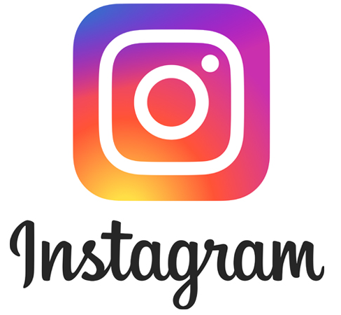
CONNECT WITH SWACSM ON SOCIAL MEDIA
https://twitter.com/sw_acsm https://www.instagram.com/swacsm/ https://www.facebook.com/SWACSM

Board of Trustees - Southwest American College of Sports Medicine
Executive Director: Ben Yaspelkis III, Ph.D., FACSM Member-at-Large: Jeffrey Bernard, Ph.D., FACSMFACSM,
President-Elect: Jenevieve Roper, Ph.D Member-at-Large: James Navalta, Ph.D
President: Trevor Gillum, Ph.D., FACSM Member-at-Large: Sarah Camhi, Ph.D.
Past-President: Kim Henige, Ed.D. Member-at-Large: Zachary Zeigler, Ph.D.
Student Representative: Cristian Faltas, M.S. Member-at-Large: Zachary Zenko, Ph.D., FACSM
Regional Representative: Ann L. Gibson, Ph.D., FACSM
Regional Representative: Ann Gibson, Ph.D.

