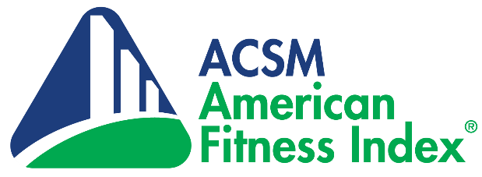

For Immediate Release

Media Contact:
NAME, TITLE
EMAIL
PHONE

[CITY] Named One of America’s Fittest Cities
in 2021 American Fitness Index® Ranking of Top 100
COVID-19 underscores need to return to basics of physical activity; food insecurity and sleep added to evidence-based indicators of holistic health

[CITY, ST.], has been named one of “America’s Fittest Cities” in the annual American Fitness Index® rankings published by the American College of Sports Medicine (ACSM) and the Anthem Foundation, the philanthropic arm of Anthem, Inc.

The science-based Fitness Index evaluated America’s 100 largest cities using 34 health behaviors, chronic diseases and community infrastructure indicators. [CITY] ranked #[OVERALL RANK] overall, #[PERSONAL HEALTH RANK] for healthy behaviors like exercising and eating fruits and vegetables and #[COMMUNITY/ENVIRONMENT RANK] for community assets like parks, playgrounds and walkable neighborhoods. You can access the full rankings and scores, summary report, city comparison tool and other insights on the American Fitness Index website at www.americanfitnessindex.org.

[INSERT QUOTE ABOUT RANKING AND EFFORTS FROM MAYOR OR OTHER LOCAL OFFICIAL]

[INSERT DETAILS ABOUT LOCAL PHYSICAL ACTIVITY, HEALTHY EATING OR INFRASTRUCTURE INTIATIVES]

“As we continue to deal with the effects of COVID-19, it is even more important that Americans get back to the basics and return to a more physically active, nutrition-conscious and healthy lifestyle,” said Stella Volpe, Ph.D., R.D.N., ACSM-CEP, FACSM, Virginia Polytechnic Institute and State University and chair of the American Fitness Index Advisory Board. “Despite the overwhelming evidence that physical activity helps prevent and manage chronic diseases, improve mental health and strengthen the immune system, most adults are still not moving enough.”

Volpe also notes that it is harder for some residents to be active because of the built environment in their neighborhoods. “Local community leaders must step up and make wise spending choices, policy decisions and infrastructure changes to enhance the ability of residents to be physically active and healthy,” she adds. “Local actions that change behaviors also reduce obesity rates, incidence of chronic disease and stress. ACSM and the Anthem Foundation now implement year-round education and outreach activities around the Fitness Index results to help identify needs in each city and contribute to potential solutions.”

Now in its 14th year, the Fitness Index offers city leaders valuable research to make potentially life-changing decisions in policy, systems and environmental change strategies to drive fitness and health improvements in their communities.

# # #

About the American College of Sports Medicine
The American College of Sports Medicine (ACSM) serves as the largest sports medicine and exercise science organization in the world with more than 50,000 international, national and regional members and certified fitness professionals. All are dedicated to advancing and integrating scientific research to provide educational and practical applications of exercise science and sports medicine. ACSM advocates for legislation that supports continued funding of parks, trails and safe routes to school; the need for all Americans to meet the physical activity recommendations included in the National Physical Activity Guidelines; as well as the need for the guidelines to be regularly updated every 10 years. Find more details at www.acsm.org.

About the Anthem Foundation
The Anthem Foundation is the philanthropic arm of Anthem, Inc., and through charitable contributions and programs, the Foundation promotes the inherent commitment of Anthem, Inc. to enhance the health and well-being of individuals and families in communities that Anthem, Inc. and its affiliated health plans serve. The Foundation focuses its funding on strategic initiatives that make up its Healthy Generations Program, a multi-generational initiative that targets: maternal health, diabetes prevention, cancer prevention, heart health and healthy, active lifestyles, behavioral health efforts and programs that benefit people with disabilities. The Foundation also coordinates the company’s year-round Dollars for Dollars program which provides a 100% match of associates’ donations, as well as its Volunteer Time Off and Dollars for Doers community service programs. To learn more about the Anthem Foundation, please visit http://www.anthem.foundation and its blog at https://medium.com/anthemfoundation.

