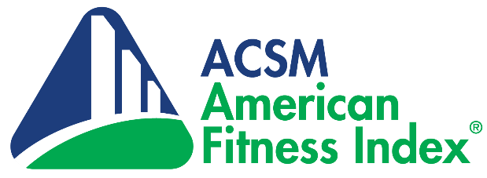

[CITY] Named One of America’s Fittest Cities
in 2021 American Fitness Index Ranking

[CITY] has been named one of “America’s Fittest Cities” in the14th annual ACSM American Fitness Index. The Fitness Index evaluated America’s 100 largest cities using 34 health behaviors, chronic diseases, and community infrastructure indicators.

[CITY] ranked #[OVERALL RANK] overall, #[PERSONAL HEALTH RANK] for healthy behaviors like exercising and eating fruits and vegetables and #[COMMUNITY/ENVIRONMENT RANK] for community assets like parks, playgrounds and walkable neighborhoods

[INSERT DETAILS ABOUT LOCAL PHYSICAL ACTIVITY, HEALTHY EATING OR INFRASTRUCTURE INTIATIVES]

“As we continue to deal with the effects of COVID-19, it is even more important that Americans get back to the basics and return to a more physically active, nutrition-conscious and healthy lifestyle,” said Stella Volpe, Ph.D., R.D.N., ACSM-CEP, FACSM, Virginia Polytechnic Institute and State University and chair of the American Fitness Index Advisory Board. “Despite the overwhelming evidence that physical activity helps prevent and manage chronic diseases, improve mental health and strengthen the immune system, most adults are still not moving enough.”

The American College of Sports Medicine, with support from the Anthem Foundation, ranks the health and fitness of the country’s largest cities because fit cities attract new residents and businesses, raise property values, improve the environment, lower health care costs, enhance quality of life and, ultimately, produce healthier residents and communities.

See how [CITY] compares to the other fittest cities in America with the city comparison tool at www.americanfitnessindex.org/rankings!

Follow the American Fitness Index on Facebook and Twitter for the latest news and helpful resources from ACSM and join the discussion by using the hashtag #100fitcities.

